**1DAILY ASSESSMENT FORMAT**

|  |  |  |  |
| --- | --- | --- | --- |
| **Date:** | **18/05/2020** | **Name:** | **K GAURAV SHET** |
| **Course:** | **TCSiON(Knockdown the lockdown)** | **USN:** | **4AL18EC023** |
| **Topic:** | **Day 1:Communicate to impress** | **Semester & Section:** | **ECE ,4th sem** |
| **Github Repository:** | **GSHET** |  |  |

|  |
| --- |
| **FORENOON SESSION DETAILS** |
| **Image of session** |
| **Report – Report can be typed or hand written for up to two pages.** |

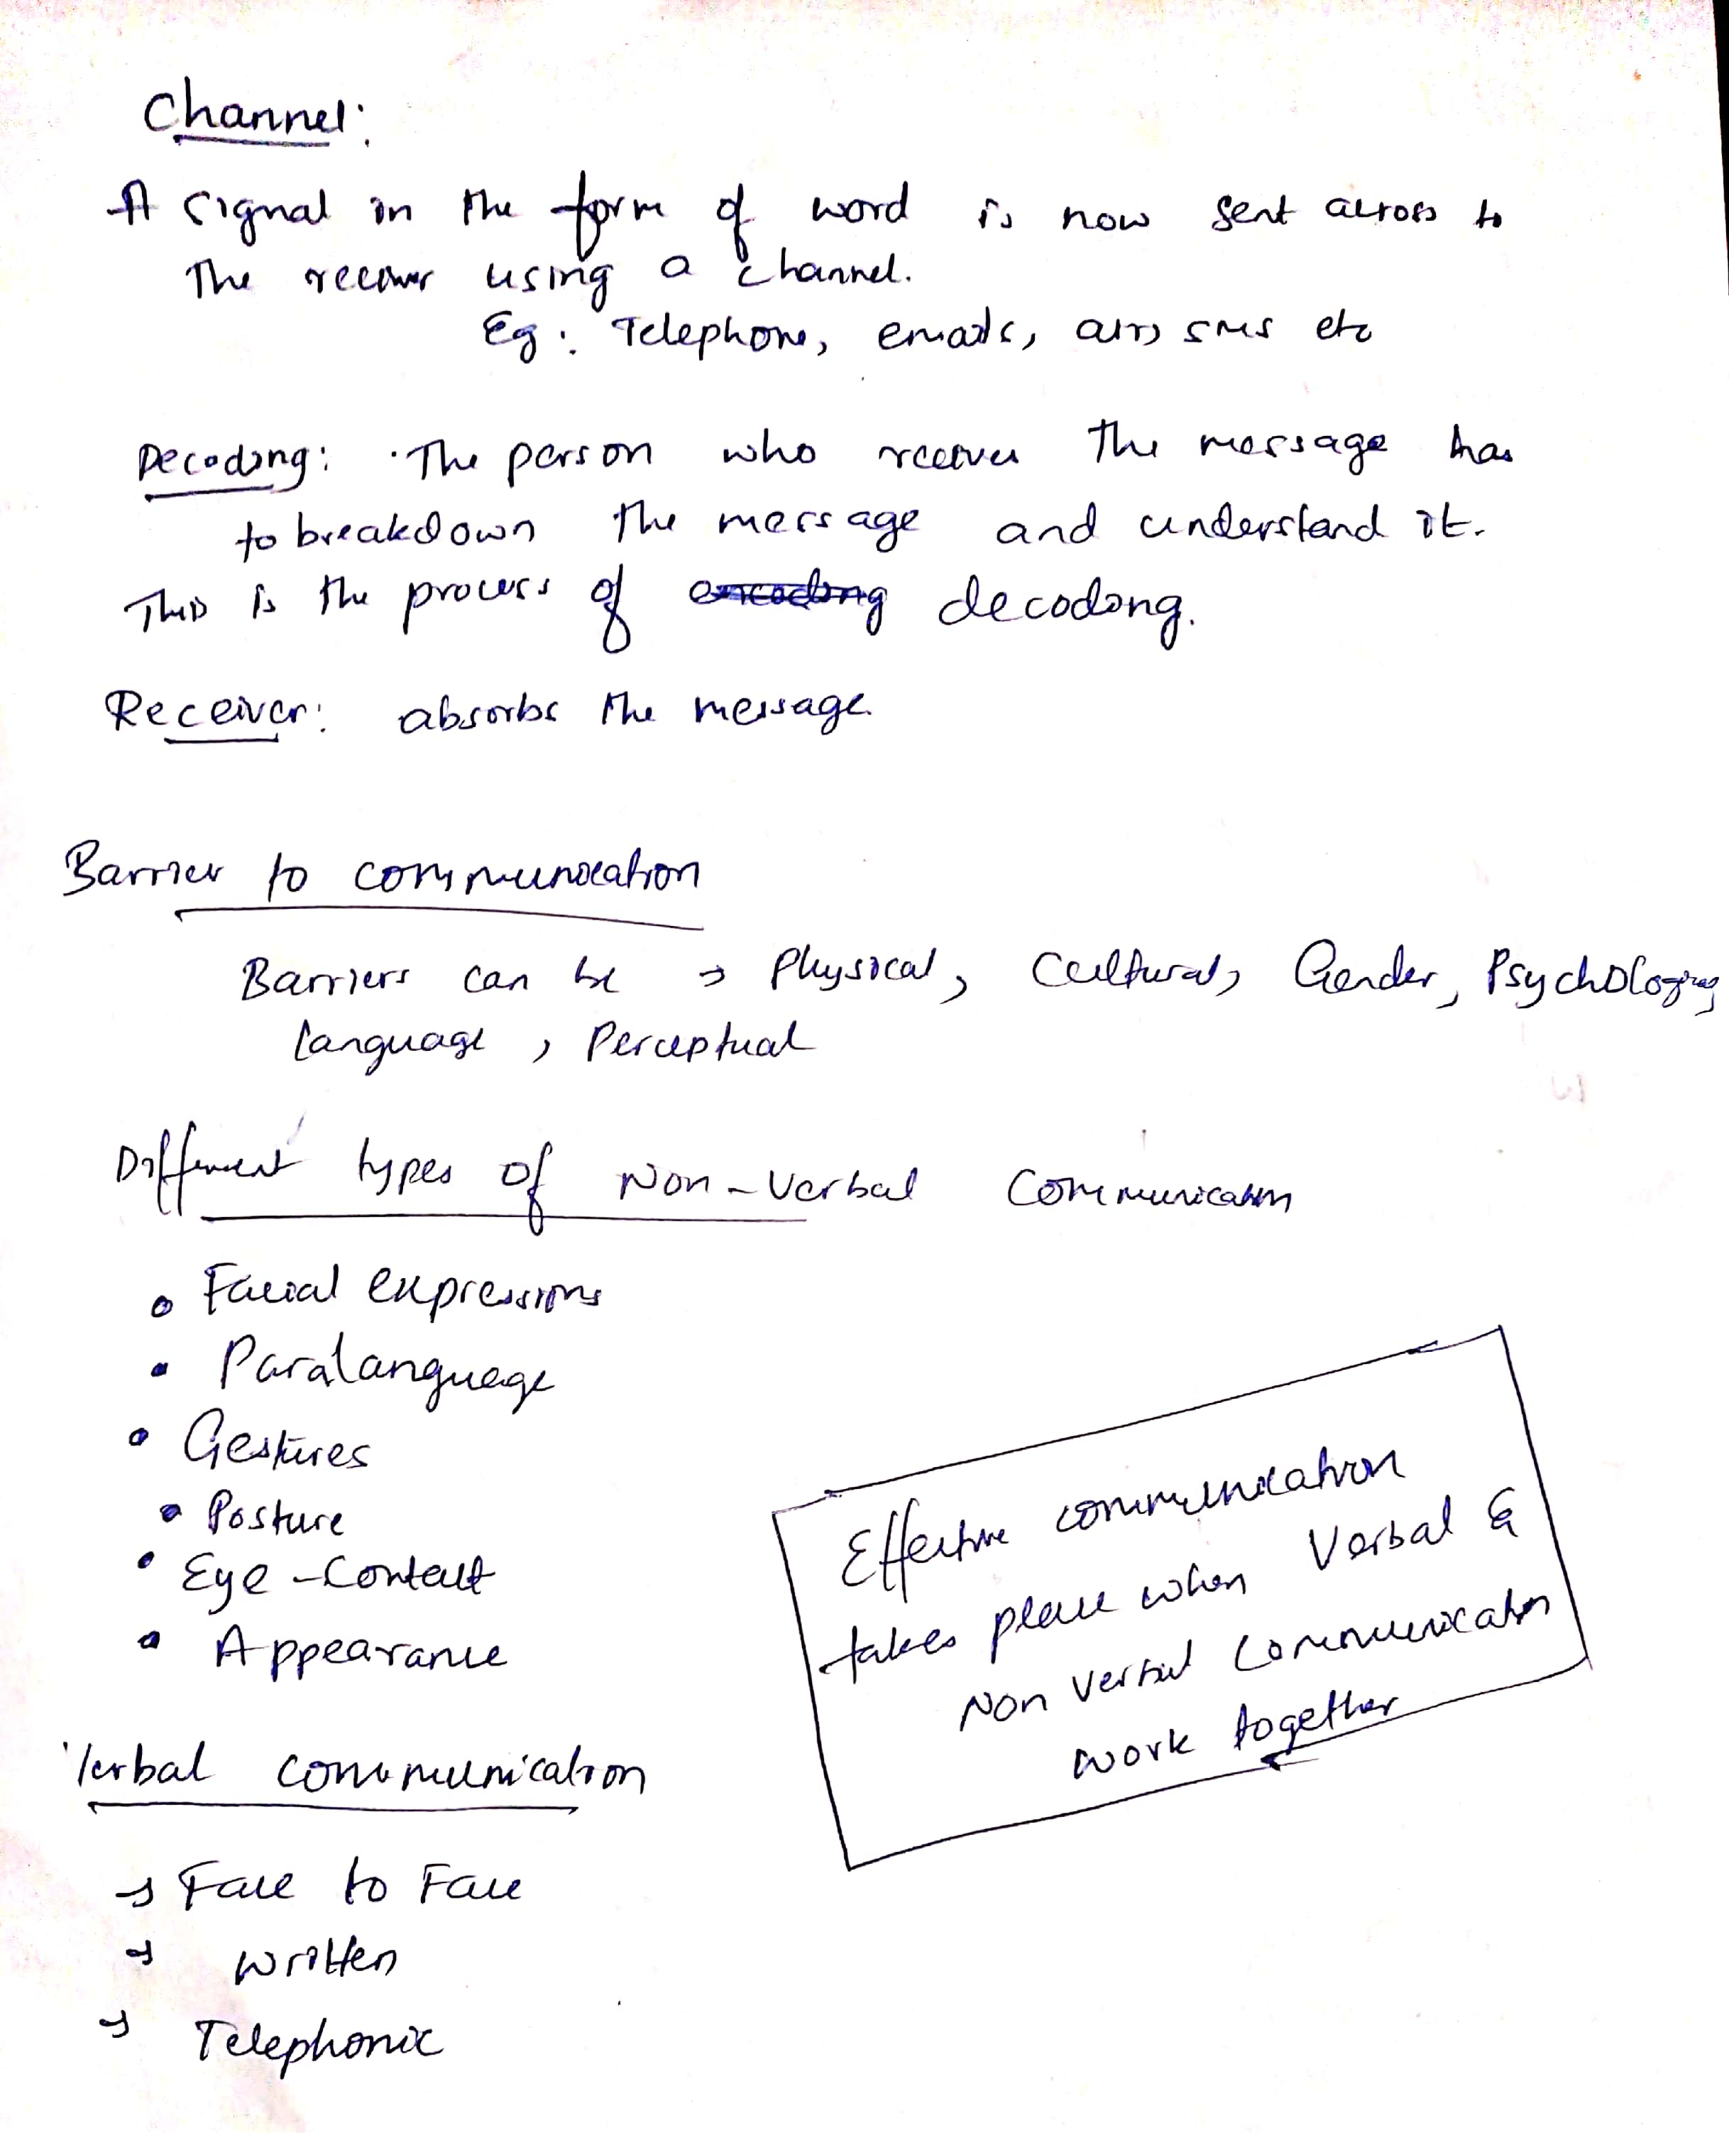

|  |  |  |  |
| --- | --- | --- | --- |
| **Date:18/05/2020** | **Name:** | **K GAURAV SHET** |  |
| **Course:TCSiON(Knockdown the lockdown)** |  | **USN:4al18ec023** |  |
| **Topic:day2 and day 3(deliver presentation with impact ,develop soft skill)** |  | **Semester & Section:ECE ,4thsem** |  |
| **AFTERNOON SESSION DETAILS** | | | |
| **Image of session** | | | |
|  | | | | |

